PhD VIVA VOCE
Candidate Name: | Tukumbukege Ibengwe | 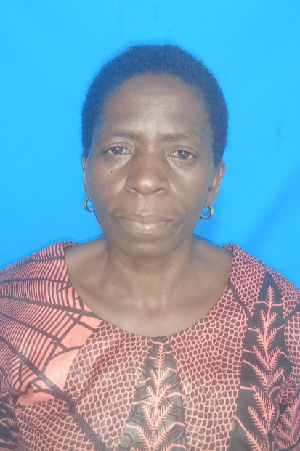
Registration Number: | 2018-07-00009
 | University of Dar es Salaam
 | School of Education

Qualifications attained:
Ms. Tukumbukege Ibengwe is a PhD (Education) student (Coursework and Dissertation) in the Department of Educational, Foundations, Management, and Lifelong Learning (EFMLL), University of Dar es Salaam. She holds a Diploma in Education from Morogoro Teachers College in 1999 and the Diploma in Adult education from the Institute of Adult Education (IAE) in 2005. Tukumbukege obtained both Bachelor in Adult Education in 2009 and Masters of Art in Education in 2013 from the University of Dar es Salaam. Currently, she is a PhD candidate with research title “Determinants of Students’ Performance in the Certificate of Secondary Education Examination in the non-Formal Education System in Dar es Salaam, Tanzania”. She was employed by Prime Ministry Office of Regional Administration and Local Government (PMO-RALG) from 1999 – 2015 as a primary school teacher. Currently, Ms. Tukumbukege is employed by the Ministry of Education, Science, and Technology in the Department of School Quality Assurance as District School Assurance Officer (DSQAO).
Title of Dissertation: | Determinants of Students’ Performance in the Certificate of Secondary Education Examination in the non-Formal Education System in Dar es Salaam, Tanzania
Date of Viva Voce: | 1st November 2022
Venue : | Board Room-SoED
Time : | 10:00 a.m
Supervisor : | Dr. Yohana William

ABSTRACT
This study investigated the determinants of students’ performance in the CSEE in the non-formal secondary education system in Dar es Salaam region, Tanzania. The study employed a quantitative research approach using a cross-sectional survey research design. It involved a sample of 30 open secondary schools and 454 students in these schools. The sample was obtained through stratified and simple random sampling techniques. Data was collected through a Likert scale questionnaire and analysed using descriptive and inferential statistics, namely, Pearson correlation and multiple linear regressions. The results of the Pearson correlation revealed that there was a positive and significant correlation between students’ performance and demographic factors r (452) =.16, P=.001), duration of the study r (452) =.52, P=.000), and aspirations of students r (452) = .98, P = .038). However, the correlation between demographic factors and students’ performance was very low, implying that demographic factor was not a strong reason or determinant of poor students’ performance in the CSEE in non-formal secondary education. The findings also showed that the aspirations of students were the leading causes of poor students’ performance in the CSEE; hence, the prime factor that determines students’ performance in this system of education. The observed results, P values were less than the level of significance (.05) at which null hypotheses were tested. Therefore, all null hypotheses were rejected. In multiple linear regressions analysis, the findings showed that the variables significantly predicted the outcome variable given the data R² =.534, F (3, 450) = 24.46, P = .003. The degree of variability (R²) was 53 per cent and adjusted R square .503. Multiple linear regressions also indicate how individual variable was related to students’ performance as follows: aspirations of students (β=.909, P = .046), duration of the study (β=.890, P=.048), and demographic factors (β=.317, P =.647). These findings implied that the aspirations of students and the duration of the study significantly predicted students’ performance. The study came up with the major conclusion that poor students’ performance in the CSEE resulted from the aspirations of students in this system of education. The study recommends that teaching and learning in non-formal secondary education should be based on the aspirations of students to achieve their learning goals in this system of education.
Panel Members
No | Name | Designation | Rank | Unit
 | Prof. Abel Ishumi | Chairperson | Professor Emeritus | SoED-EFMLL
 | Dr. Blackson Kanukisya | Representing External Examiner | S/Lecturer | SoED-EFMLL
 | Dr. Philipo L. Sanga | Internal Examiner | S/Lecturer | SoED-EFMLL
 | Dr. Yohana William | Candidate’s Supervisor | Lecturer | SoED-EFMLL
 | Dr. Nkanileka Mgonda | Head of the relevant department (or his/her appointee) | S/Lecturer | SoED-EFMLL
 | Dr. Albert Tarmo | Co-opted Member (appointed by College/School/Institute | S/Lecturer | SoED-EPCS
 | Dr. Gennes Shirima | Co-opted Member (appointed by College/School/Institute | Lecturer | SoED-EFMLL
 | Dr. Joel Kayombo | Appointee of the Principal for PhD only) | S/Lecturer | DUCE-EFMLL

